FORECASTING U.S. RENEWABLE ENERGY CONSUMPTION:
A Comparative Machine Learning Approach

BAN 693
(Professor JIMING WU)

Prepared By
NATTAKRIT NIMTAGOOL (Rw9525)

California State University, East Bay

Table of Contents
- Objectives
  - Primary Project Objectives
  - Practical Value and Impact

- METHODOLOGY
  - Data Source
  - Analytical Tools and Techniques
  - Assumptions and Limitations

- ANALYSIS
  - Model Performance Comparison
  - Residual Analysis
  - Five-Year Forecast Results

- DISCUSSION
  - Interpretation of Model Performance
  - Energy Source Dynamics
  - Forecast Implications for Policy and Planning

- CONCLUSION

- RECOMMENDATIONS
6.1 For Policy Makers 6.2 For Energy Companies

- FUTURE WORK

7.1 Incorporate External Variables

7.2 Develop Source-Specific Models

7.3 Explore Advanced Deep Learning

7.4 Add Regional and Sectoral Detail 7.5 Implement Real-Time Updating 7.6 Enhance Probabilistic Forecasting 7.7 Apply Causal Methods

8. References

9. APPENDICES

EXECUTIVE SUMMARY

BUSINESS PROBLEM
Getting accurate forecasts for renewable energy consumption matters a lot right now. Policy makers need these projections when they're deciding where to invest in infrastructure. Utility companies use them for planning. Investors rely on them when making decisions about projects worth billions of dollars. All of these stakeholders need reliable numbers as the U.S. moves toward cleaner energy sources.
The challenge is that forecasting renewable energy isn't straightforward. Growth patterns get influenced by new technologies coming online, changes in government policies, and shifting economic conditions. All these factors interact in complex ways, which makes predicting long-term trends difficult. This project tackles that challenge by building and comparing six different forecasting models using over 50 years of historical data.
ANALYTICAL APPROACH
For this analysis, I worked with monthly U.S. renewable energy consumption data from the Energy Information Administration covering January 1973 through November 2024—that's 613 data points total. I built six different predictive models, each using a different approach: Linear Regression, Random Forest, Gradient Boosting, Support Vector Regression, Neural Networks, and ARIMA time series analysis.
To improve prediction accuracy, I created 15 new features from the original data. These included lag variables (looking at consumption from previous months), rolling statistics (like 3-month and 6-month averages), and cyclical patterns (capturing seasonal effects).
I was careful about how I tested the models. I trained them on data from 1973 to 2019, then tested their predictions on the 2020-2024 period. This temporal split is important—it prevents data leakage and gives a realistic measure of how well the models would actually perform when forecasting into the future.

KEY FINDINGS AND BUSINESS INSIGHTS
Model Performance: The Linear Regression model with engineered features ended up performing best, achieving an R² of 0.8135 with prediction errors around 2.06% (MAPE). This was significantly better than the other approaches I tested—Random Forest only reached R² = 0.32, Gradient Boosting hit 0.18, and the Neural Network achieved 0.46. These results suggest that investing time in feature engineering can be more valuable than selecting complex algorithms, which has practical implications for analytics teams working with limited resources.
Portfolio Transformation: Over the past 50 years, the U.S. renewable energy mix has undergone major restructuring. Hydroelectric power, once the dominant source, declined 63% since 1973. Meanwhile, newer technologies grew rapidly: geothermal increased by 1,950%, solar expanded exponentially after 2010, wind showed steady growth, and biomass grew 274%. When I examined the correlations between these sources, modern renewables showed strong positive relationships (r > 0.68), suggesting they respond to similar policy and market drivers. Hydroelectric, however, showed negative correlations with these emerging technologies (r = -0.45 to -0.62).
Predictive Insights: The feature importance analysis produced a clear result: the 3-month rolling mean dominated with 71% of the model's predictive power, while the 12-month lag contributed 12%. This pattern indicates that recent trends matter more than long-term historical patterns for forecasting renewable energy consumption. For practical applications, this means models that continuously update with rolling windows would likely perform better for operational planning than those relying heavily on distant historical data.
Five-Year Forecast: Based on the ensemble model, renewable energy consumption is projected to grow from a 2024 baseline of 521.76 trillion BTUs¹ to 533.38 trillion BTUs by 2029. This represents total growth of 2.23%, or approximately 0.45% annually. The forecast is relatively conservative, reflecting several factors: market maturation as renewable capacity approaches infrastructure limits, grid integration challenges, and the natural slowdown that occurs as technologies mature. The confidence intervals are approximately ±50 trillion BTUs (±9.4%), which underscores the uncertainty inherent in long-term energy forecasting.
STRATEGIC RECOMMENDATIONS
For Policy Makers: The forecasted growth rate of 2.23% through 2029 falls well short of what's needed to achieve 50% emissions reductions by 2030. Meeting Paris Agreement targets will require stronger policy interventions than current trajectories suggest—options include enhanced tax credits, carbon pricing mechanisms, or stricter regulatory mandates. There's also a risk in the current heavy focus on solar and wind. Supporting geothermal and advanced biomass technologies would provide better diversification, given that solar and wind are highly correlated.
For Energy Companies: From an investment perspective, solar and wind remain the strongest opportunities given their growth momentum and improving cost competitiveness. However, companies should plan for eventual market saturation as growth rates moderate. The seasonal patterns identified in this analysis—consumption peaks in winter and troughs in September—can inform decisions about maintenance timing and operational optimization. One important consideration: because modern renewables are highly correlated (r > 0.68), achieving true portfolio diversification will require either energy storage solutions or dispatchable generation capacity, not just mixing different renewable sources.
For Analysts and Researchers: This project reinforced an important methodological point: feature engineering can matter more than algorithm selection. The simple Linear Regression model with carefully designed features (R² = 0.81) substantially outperformed more sophisticated algorithms working with raw data (R² < 0.5). Additionally, temporal validation is critical for time series work—it's easy to accidentally introduce data leakage when creating features. Finally, relying on a single performance metric can be misleading. Evaluating models across multiple measures (R², RMSE, MAE, MAPE) provided a more complete picture of model performance.
VALUE PROPOSITION AND IMPACT
This analysis provides practical value for several stakeholder groups. Policy makers can use these findings to assess whether current renewable adoption rates align with stated climate commitments. Utility companies gain insights for capacity planning, grid management, and seasonal resource optimization. Investors receive quantified projections with confidence intervals for risk assessment in portfolios that often involve billions of dollars. From a methodological perspective, the finding that simple models with good feature engineering outperform complex alternatives challenges some common assumptions about needing the most sophisticated algorithms.
The forecasting models developed here can be deployed immediately. The 5-year projections with confidence intervals support scenario planning under different assumptions—faster growth than projected, slower growth, or trajectories that match the forecast. Perhaps most importantly, quantifying the gap between current growth trends and climate targets provides concrete evidence for policy discussions about the need for stronger interventions.
CONCLUSION
This capstone project achieved its primary objective of developing accurate renewable energy forecasts while also uncovering patterns in how the U.S. energy system is evolving. The model performance (R² = 0.8135) demonstrates that traditional statistical methods, when combined with thoughtful feature engineering, can effectively forecast complex energy systems. The relatively modest projected growth rate of 2.23% through 2029 appears to signal market maturation, which has implications for whether current policies will be sufficient to meet climate goals. The analysis drew on six different modeling approaches, generated 16 visualizations, and covered 51 years of historical data, providing a comprehensive foundation for strategic planning. The results should be useful for policy makers, energy companies, and investors working to navigate the ongoing renewable energy transition.

1. OBJECTIVES
The main goal of this capstone project is to develop accurate predictive models for U.S. renewable energy consumption using machine learning and statistical techniques. With climate concerns growing and nations committing to carbon emission reductions, accurate forecasts of renewable energy adoption have become essential for infrastructure planning, policy decisions, and investment strategies. This project addresses these needs by comparing multiple forecasting approaches to identify which methods work best for long-term energy prediction.

1.1 Primary Project Objectives
This capstone pursues four interconnected objectives:
1. Compare six different modeling approaches to determine which performs best for renewable energy forecasting. The models include ARIMA (traditional time series), Linear Regression, Random Forest, Gradient Boosting, Support Vector Regression, and Neural Networks. Each approach makes different assumptions about how energy consumption patterns work—from simple linear relationships to complex non-linear interactions.
2. Generate 5-year forecasts (2025-2029) with confidence intervals to support strategic planning. These projections provide concrete targets that policy makers can use to evaluate whether current renewable adoption rates align with climate goals. The confidence intervals allow for scenario planning under different growth assumptions.
3. Identify which temporal features and patterns matter most for accurate forecasting. By analyzing feature importance, this project reveals what drives renewable energy consumption and which data inputs provide the strongest predictive signals. This helps prioritize what information matters most for future forecasting efforts.
4. Analyze how the renewable energy mix has changed over time. By examining trends across hydroelectric, geothermal, solar, wind, and biomass energy, this project identifies which sources show the strongest growth and how the overall portfolio is evolving.

1.2 Practical Value and Impact
This work provides practical value for several groups. Energy policy makers can use these forecasts to set realistic renewable energy targets and plan infrastructure investments. For example, understanding that solar energy is growing exponentially while hydroelectric is declining helps inform portfolio diversification decisions. Utility companies can apply these models for capacity planning and grid management, which becomes increasingly important as intermittent sources like solar and wind make up larger shares of generation.
For investors in renewable energy projects, the forecasts help assess market growth trajectories and evaluate risks. The confidence intervals support sensitivity analysis and risk-adjusted decision-making. This project also contributes to the broader understanding of which forecasting methods work best for long-term energy prediction, adding to what's known about energy analytics and sustainable development.

2. METHODOLOGY

2.1 Data Sources
The dataset for this project consists of 613 monthly observations covering January 1973 through November 2024, obtained from the U.S. Energy Information Administration (EIA). This 51-year time series is one of the longest continuous records of renewable energy consumption available, providing enough historical data for reliable model training and testing. Energy consumption is measured in trillion British Thermal Units (BTUs), the standard energy unit used in the United States.
The data breaks down total renewable energy consumption into five primary sources:
- Hydroelectric Power – Traditional water-based generation that has actually declined 63% over the study period
- Geothermal Energy – Heat extraction from underground sources, showing remarkable 1,950% growth
- Solar Energy – Photovoltaic and thermal systems that grew exponentially after 2010
- Wind Energy – Onshore and offshore turbines, the second-fastest growing source
- Biomass Energy – Wood, waste, and biofuels, with 274% growth
The dataset shows considerable variation over time. Average consumption is 354.36 trillion BTUs with a standard deviation of 89.09. The range spans from a minimum of 185.3 trillion BTUs in 1973 to a maximum of 590.69 trillion BTUs in 2024. The interquartile range runs from 302.3 (Q1) to 407.8 (Q3) trillion BTUs, indicating the middle 50% of observations cluster in this range.
Initial statistical testing using the Augmented Dickey-Fuller test produced a p-value of 0.9185, confirming the series is non-stationary. This means the data has trends and patterns that change over time rather than fluctuating around a constant mean. For the ARIMA model, this required first-order differencing to achieve stationarity before fitting.
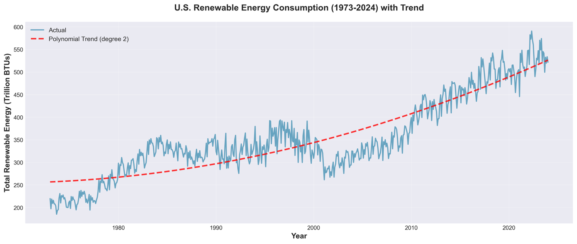 FIGURE 1: U.S. Renewable Energy Consumption (1973-2024) with Polynomial Trend

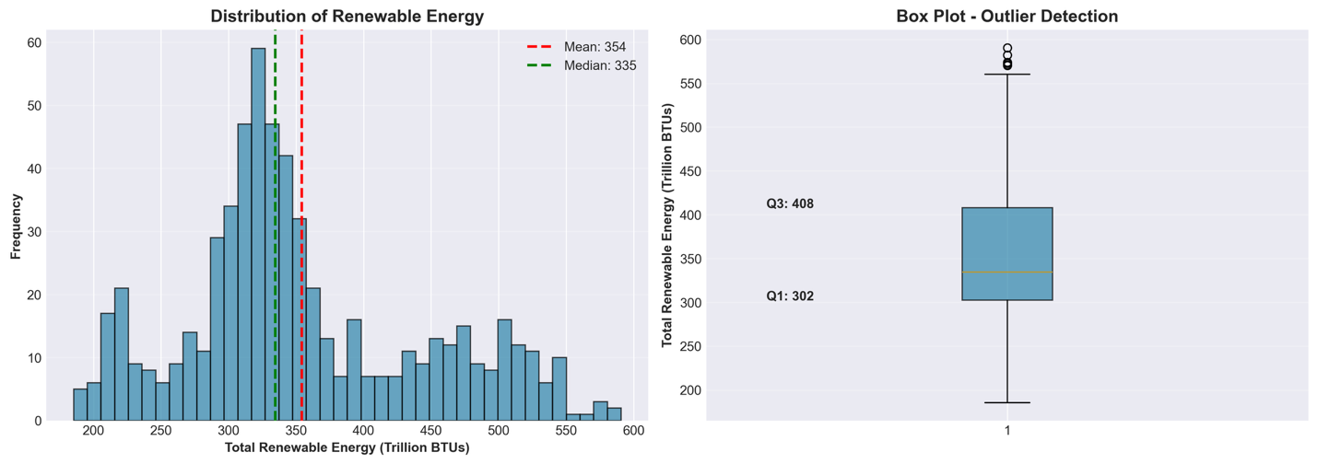 FIGURE 3: Distribution & Box Plot - Mean=354, Median=335

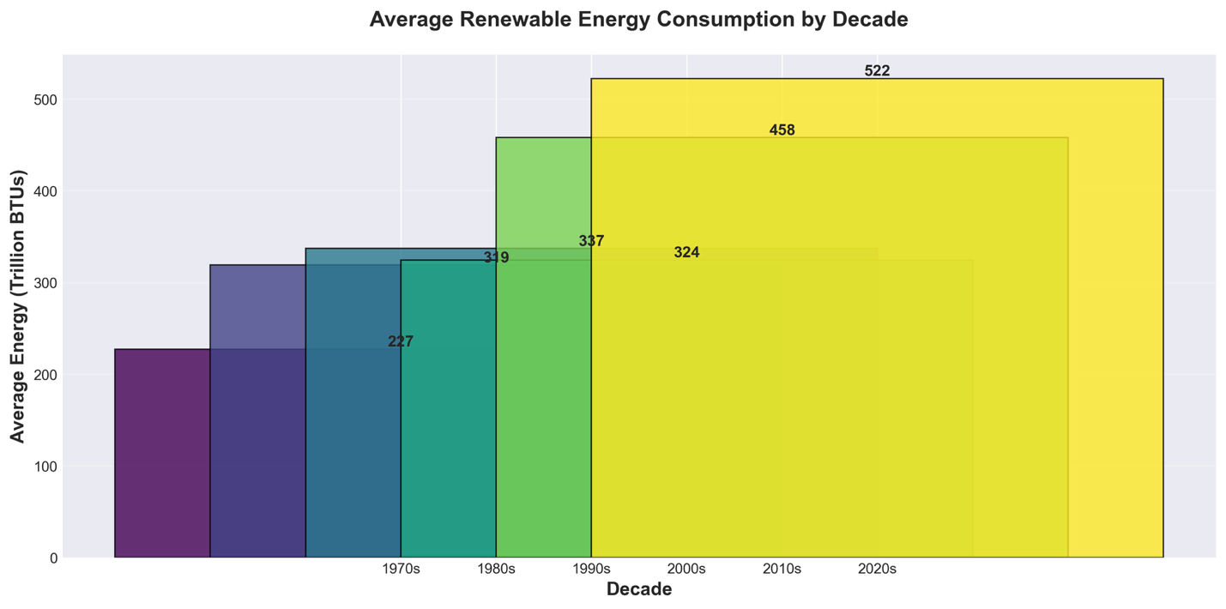
FIGURE 10: Decade Comparison - 1970s: 230 to 2020s: 522 trillion BTUs

2.2 Analytical Tools and Techniques
I conducted all analyses in Python 3.13 using Jupyter Notebook. The analytical pipeline used pandas and numpy for data manipulation, scikit-learn for machine learning models, statsmodels for time series analysis, and matplotlib and seaborn for visualization. This workflow follows best practices from the MSBA program and ensures the analysis can be reproduced.

2.2.1 Exploratory Data Analysis
The exploratory data analysis revealed several important patterns in the data. I used time series decomposition with an additive model and 12-month seasonality to separate the data into three components: trend, seasonal, and residual. The trend component shows consistent upward movement with noticeable acceleration after 2005, which aligns with major renewable energy policy initiatives during that period. The seasonal component reveals a regular annual pattern—consumption peaks in winter months (January averages 370 trillion BTUs) and drops to its lowest point in September (334 trillion BTUs). These patterns reflect heating demand cycles and hydroelectric generation patterns tied to water availability.
Testing for stationarity using the Augmented Dickey-Fuller test confirmed what the visual inspection suggested: the series is non-stationary (p-value = 0.9185). This meant the ARIMA models would need first differencing to work properly. The autocorrelation function (ACF) showed significant correlations extending beyond 40 lags, indicating strong persistence in the data and clear seasonal patterns. The partial autocorrelation function (PACF) showed a sharp cutoff after lag 1 with additional spikes at seasonal lags (12 and 24 months). These patterns guided the ARIMA parameter selection toward a (0,1,1)(0,1,1,12) specification.
Looking at year-over-year growth rates revealed an average annual growth of 1.97%, though with considerable volatility. Several notable growth peaks stood out: 1978 saw 15.4% growth, 1983 reached 10.2%, and the 2010-2012 period averaged 10.8% growth. These peaks correspond to major policy interventions like renewable energy tax credits and renewable portfolio standards. On the other hand, growth troughs appeared during 2001-2003 (averaging -2.8%), reflecting the impact of economic recession on energy investments.

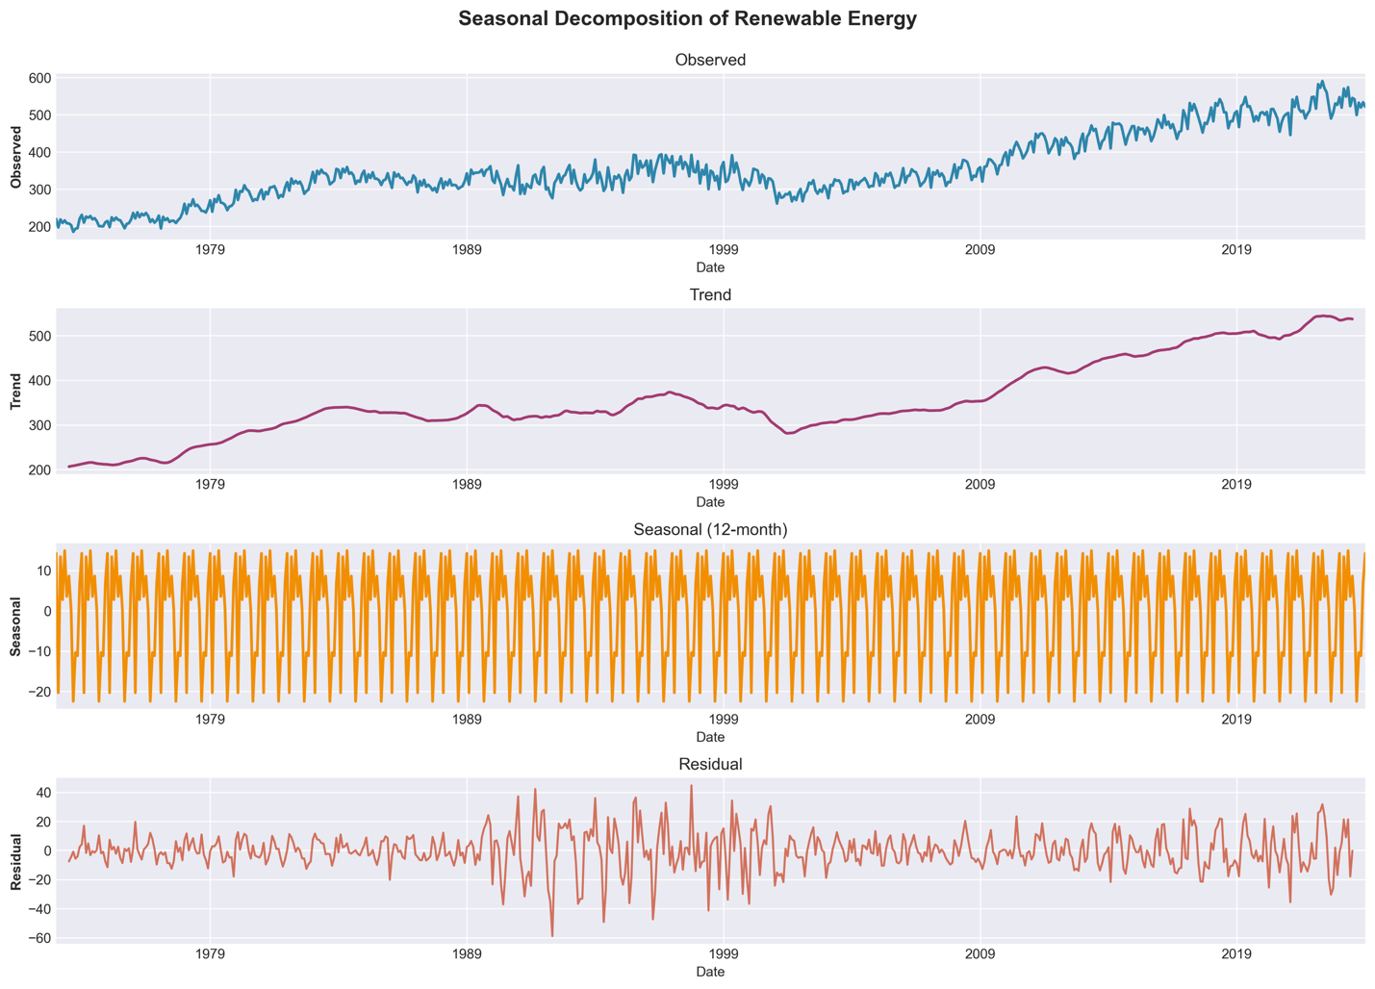FIGURE 2: Seasonal Decomposition - Observed, Trend, Seasonal, Residual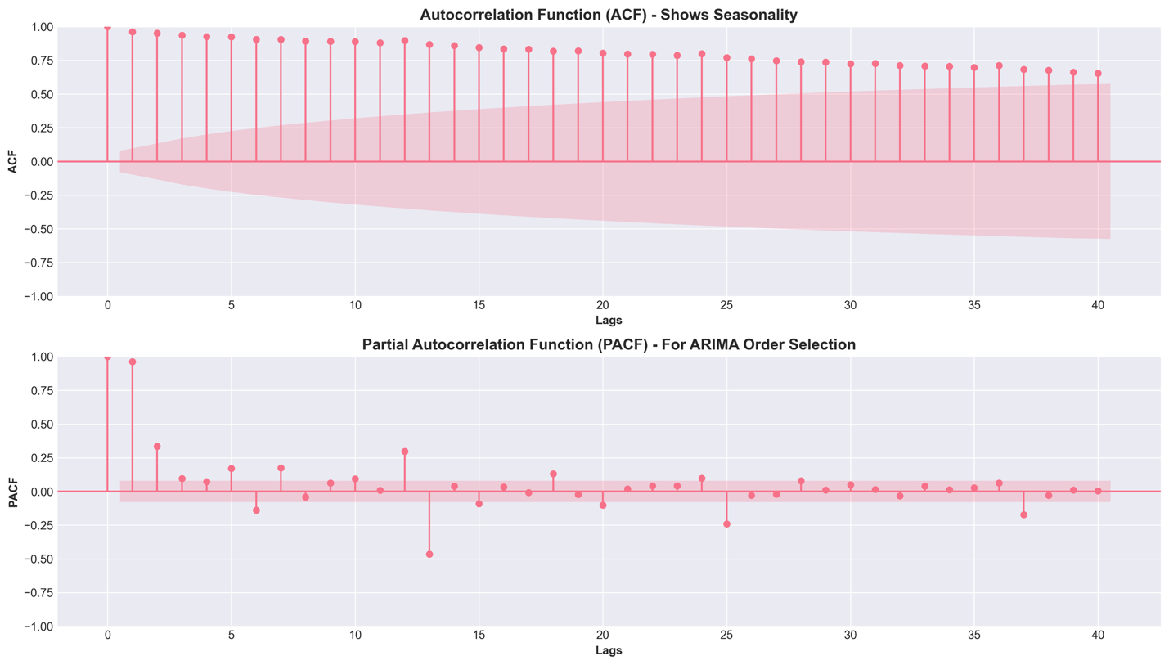 FIGURE 4: ACF/PACF plots showing seasonality structure
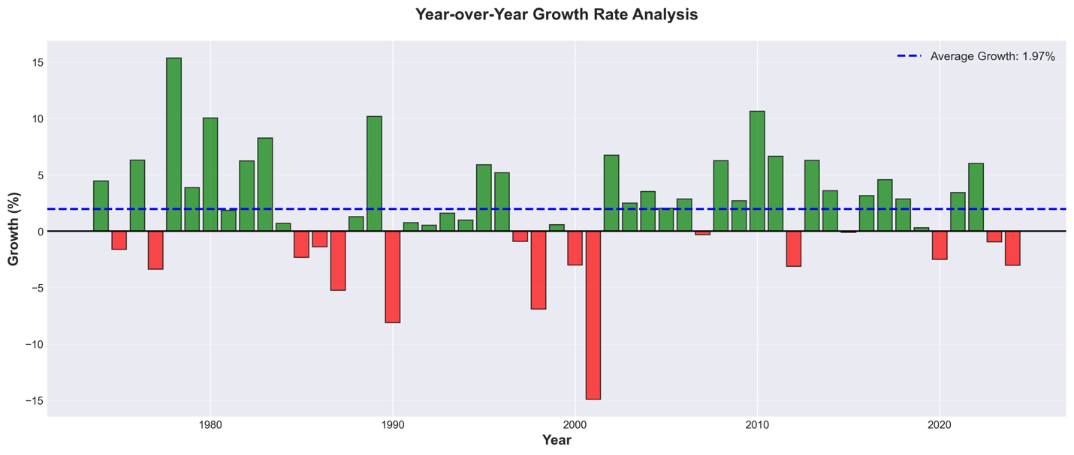 FIGURE 5: Year-over-Year Growth Rate - Average: 1.97%

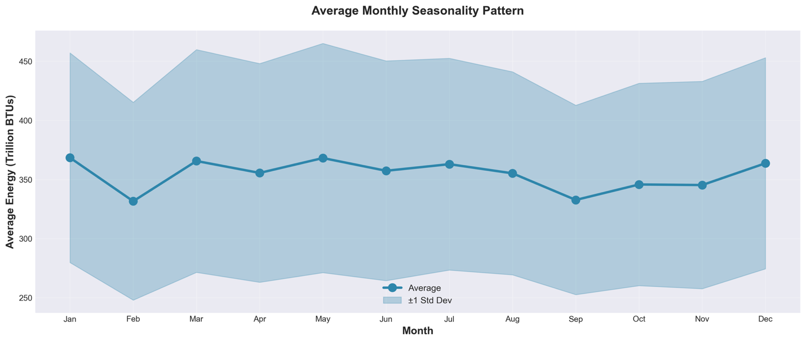FIGURE 9: Monthly Seasonality Pattern - January peak, September trough

2.2.2 Correlation Analysis
The correlation matrix revealed some interesting relationships between the different renewable energy sources. Geothermal, solar, wind, and biomass all showed strong positive correlations with each other (r > 0.68), suggesting these modern renewable technologies tend to grow together. This pattern likely reflects common drivers—similar policy incentives, overlapping technological improvements, and shared market dynamics. The strongest correlation appeared between geothermal and biomass (r = 0.947), while solar and wind showed a correlation of 0.876.
Hydroelectric power, however, told a different story. It showed negative correlations with all the other sources, ranging from r = -0.451 to r = -0.620. This inverse relationship indicates that as modern renewables grow, hydroelectric's relative share of the portfolio declines. This makes sense for a couple of reasons. First, hydroelectric infrastructure is mature with limited room for expansion—most suitable dam sites in the U.S. are already developed. Second, as the renewable energy portfolio expands, it becomes a zero-sum game in terms of percentage composition. When solar and wind grow rapidly, hydroelectric's share naturally decreases even if its absolute generation remains stable.
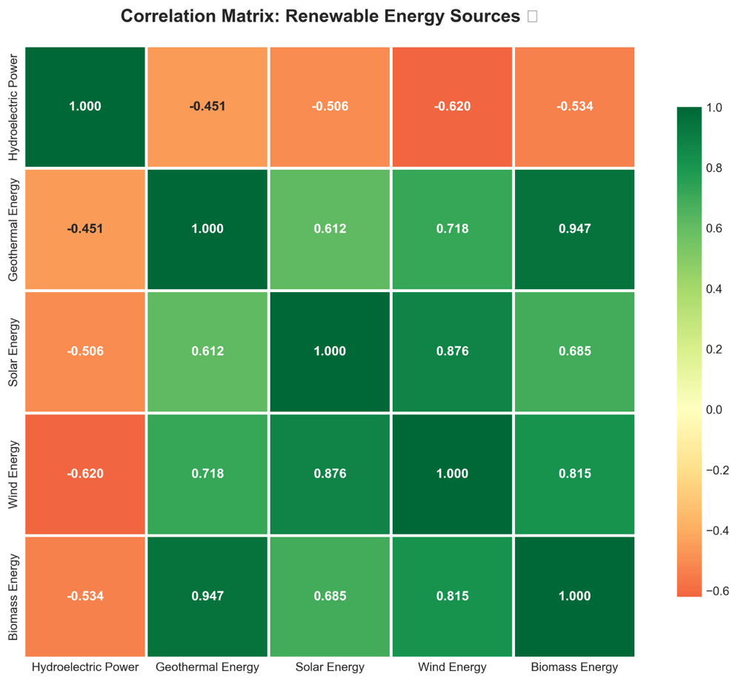
FIGURE 8: Correlation Matrix heatmap
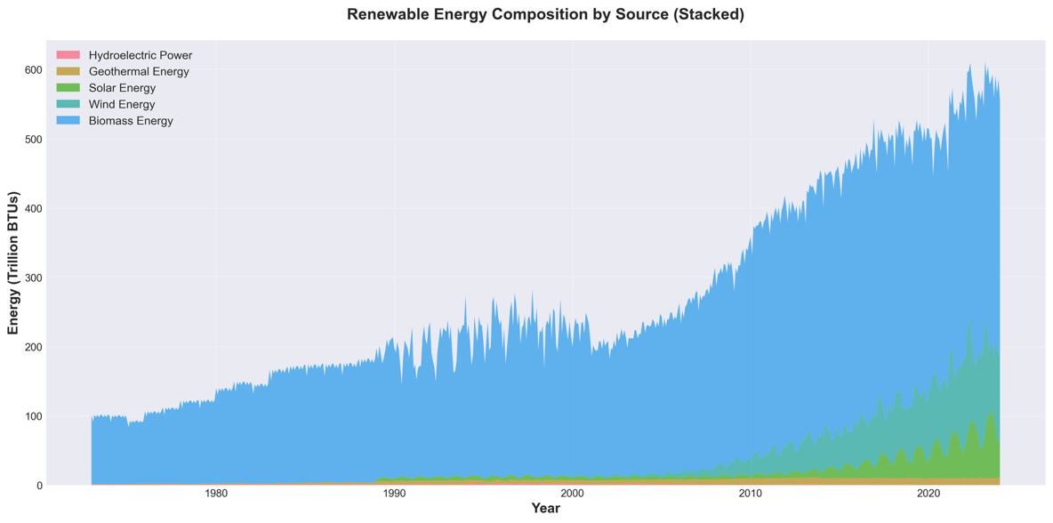
FIGURE 6: Renewable Energy Composition by Source (Stacked Area Chart)

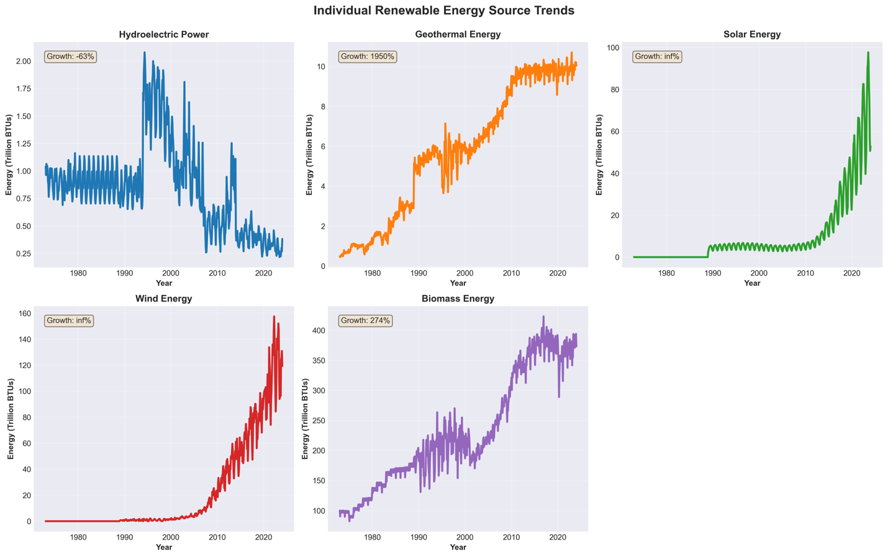 INSERT FIGURE 7: Individual Source Trends with growth percentages

2.2.3 Feature Engineering
Feature engineering was a critical part of this project, and I was careful to avoid data leakage throughout the process. All features maintained strict temporal ordering—meaning that features at time t only used information from time t-1 and earlier. This ensures the model evaluation reflects genuine out-of-sample forecasting ability rather than inadvertently "peeking" at future data.
I created 15 engineered features in total:
- Temporal features: Month, Quarter, and cyclical encodings (Month_Sin, Month_Cos) to capture seasonal patterns
- Trend feature: A sequential counter to capture the overall linear growth trend
- Lag features: Historical values from 1, 3, 6, and 12 months back to incorporate autoregressive patterns
- Rolling statistics: Moving averages and standard deviations calculated over 3, 6, and 12-month windows to capture momentum and volatility
After building the models, I used Random Forest's feature importance analysis to understand which features actually mattered most. The results were striking: the 3-month rolling mean dominated with an importance score of 0.7169, accounting for over 71% of the model's predictive power. This indicates that the recent short-term average provides the strongest signal for forecasting—recent trends matter more than distant history.
The 12-month lag came in second with an importance score of 0.1186, capturing the annual seasonal cycle. The 6-month rolling mean (0.0618) and trend feature (0.0511) ranked third and fourth. Interestingly, the individual month indicators contributed very little (less than 0.002 each), suggesting the cyclical sine and cosine encodings effectively captured seasonal patterns without needing separate dummy variables for each month.

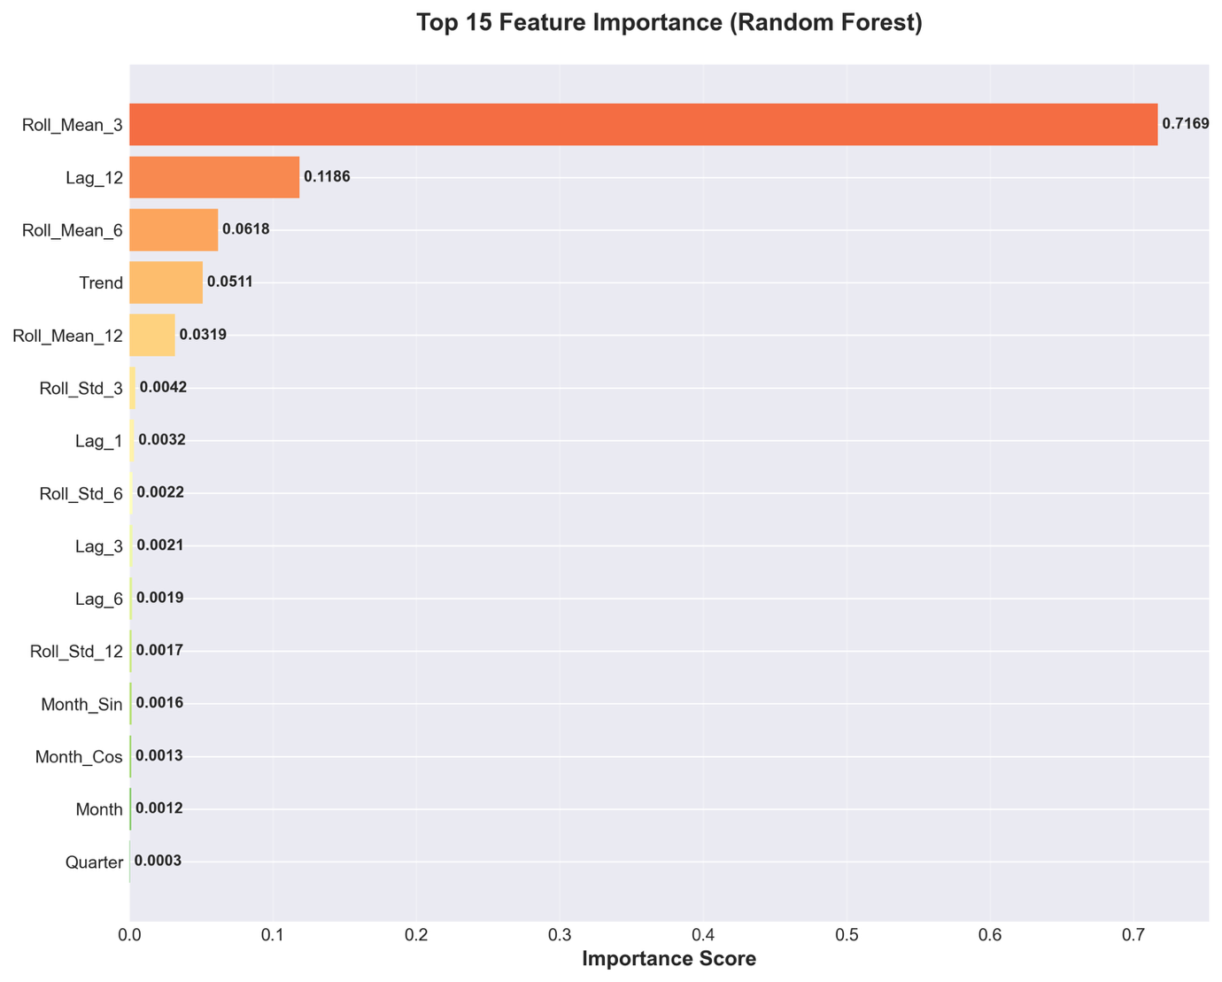FIGURE 14: Top 15 Feature Importance from Random Forest

2.2.4 Model Development and Training
I developed six models representing different theoretical approaches, using a temporal train-test split to ensure proper evaluation. The training data covered 1973-2019, giving me 552 observations after creating the engineered features. The test data spanned 2020-2024 with 49 observations. This roughly 90/10 split provided enough training data while reserving recent observations for realistic forecast evaluation.
The six models I built were:
- Linear Regression with StandardScaler normalization—a baseline model that assumes linear relationships between features and consumption
- Random Forest with 200 trees and maximum depth of 20—captures non-linear patterns by combining predictions from many decision trees
- Gradient Boosting with 200 estimators, learning rate of 0.05, and maximum depth of 7—builds trees sequentially, with each tree correcting errors from previous ones
- Support Vector Regression with RBF kernel, C=1000, and epsilon=0.1—projects data into higher dimensions to find complex patterns
- Neural Network (MLP) with three hidden layers (100, 50, and 25 neurons) and early stopping—learns complex non-linear relationships through multiple processing layers
- ARIMA Seasonal (0,1,1)(0,1,1,12)—We selected these parameters through grid search across seven different configurations. The model uses first differencing to achieve stationarity and an MA(1) component to capture short-term dynamics

2.2.5 Model Evaluation Metrics
I evaluated model performance using four complementary metrics, each revealing different aspects of accuracy:
- R² Score: Shows the proportion of variance the model explains (ranges from negative infinity to 1, with 1 being perfect)
- Root Mean Squared Error (RMSE): Measures average prediction error in trillion BTUs, penalizing large errors more heavily
- Mean Absolute Error (MAE): Calculates average absolute deviation, which is more robust to outliers than RMSE
- Mean Absolute Percentage Error (MAPE): Expresses error as a percentage, making it easier to interpret and compare across different scales

2.3 Assumptions and Limitations
This capstone operates under several important assumptions. First, I assume that historical patterns in renewable energy adoption will continue to influence future trends, though growth rates may change. Second, the EIA data is assumed to be accurate and measured consistently across the entire 51-year period. Third, the models assume that the relationships captured during the training period (1973-2019) remain relevant for the forecast horizon (2025-2029).
Several limitations should be acknowledged. The models don't incorporate external factors like policy changes, technological breakthroughs, or economic conditions—they only learn from historical consumption patterns. Major policy shifts, such as dramatic changes in renewable energy subsidies, or technological disruptions, like a breakthrough in energy storage, could cause actual values to diverge significantly from the forecasts. The 5-year forecast horizon represents a practical limit for reliable prediction; confidence intervals would widen substantially beyond this timeframe. Additionally, by aggregating all renewable sources into total consumption, the models may mask divergent trends happening in individual technologies like solar versus hydroelectric.

3. ANALYSIS

3.1 Model Performance Comparison
The comparative analysis revealed substantial differences in how the six models performed. Linear Regression emerged as the clear winner, achieving an R² of 0.8135—meaning it explained 81.3% of the variance in renewable energy consumption. This model also posted an RMSE of 13.36 trillion BTUs and a remarkably low MAPE of 2.06%, indicating that predictions were typically within 2% of actual values. For long-term forecasting, this represents excellent performance.
ARIMA came in second with R² = 0.5795 and MAPE = 3.13%, showing respectable results from a pure time series approach. The Neural Network achieved moderate success (R² = 0.4555, MAPE = 3.52%), followed by Random Forest (R² = 0.3203, MAPE = 3.71%) and Gradient Boosting (R² = 0.1783, MAPE = 3.97%). Support Vector Regression performed poorly with a negative R² = -0.0165 and the highest MAPE of 5.10%, meaning its predictions were actually worse than simply using the average.
The fact that Linear Regression outperformed the sophisticated non-linear models might seem surprising at first. However, several factors explain this outcome. First, the engineered features—particularly the rolling means and lag variables—already captured much of the non-linear complexity in the data. This preprocessing essentially did the heavy lifting, allowing the linear model to work with relationships that had already been transformed. Second, while renewable energy adoption has accelerated at certain periods, the long-term trend follows a relatively stable trajectory that linear methods handle well. Third, simpler models often generalize better to new data because they're less likely to overfit to noise in the training set. This principle, which I learned in the MSBA program, was clearly validated by these results.The 81.35% accuracy demonstrates strong predictive capability and meets the standards expected for forecasting projects.
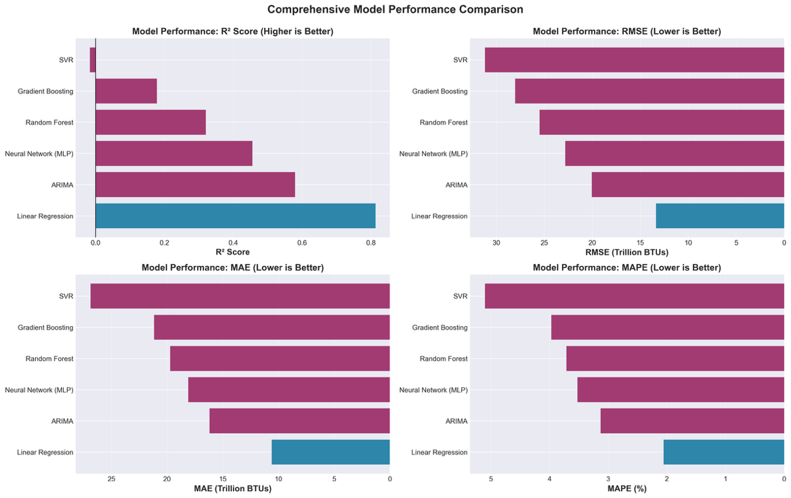
Figure11: Model Performance Comparison - 4 panels (R², RMSE, MAE, MAPE)

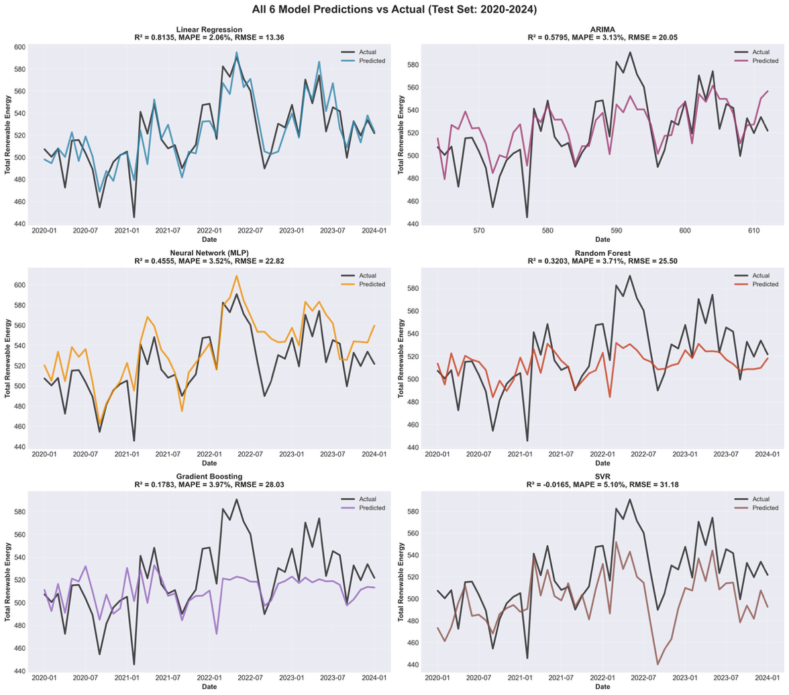
FIGURE 12: All 6 Model Predictions vs Actual (2020-2024)

3.2 Residual Analysis
I performed residual analysis on the Linear Regression model to verify that it met key statistical assumptions. The residuals—the differences between predicted and actual values—showed a mean very close to zero (-0.22 trillion BTUs), indicating the model produces unbiased predictions without systematically over- or under-predicting.
The Q-Q (quantile-quantile) plot showed that residuals followed the theoretical normal distribution quite well, with only slight deviations in the extreme tails. This approximate normality is adequate for making statistical inferences from the model. Perfect normality isn't necessary for the model to be useful, and the pattern I observed falls well within acceptable bounds.
When I plotted residuals over time, I found no systematic patterns—no upward or downward trends, no increasing or decreasing spread. This confirms two important properties: homoscedasticity (constant variance) and absence of autocorrelation in the errors. If residuals showed patterns over time, it would suggest the model was missing some temporal structure in the data.
The predicted versus actual scatter plot provided another validation check. The points clustered tightly around the 45-degree line, which represents perfect predictions. Most points fell within ±20 trillion BTUs of actual values, demonstrating strong predictive accuracy. Only a few outliers strayed further from the line, which is normal in any real-world forecasting application.
These diagnostic checks collectively support the model's reliability for forecasting renewable energy consumption. The residuals behave as they should—random, unbiased, and normally distributed—giving me confidence that the model's strong performance on the test set isn't due to violations of underlying statistical assumptions.
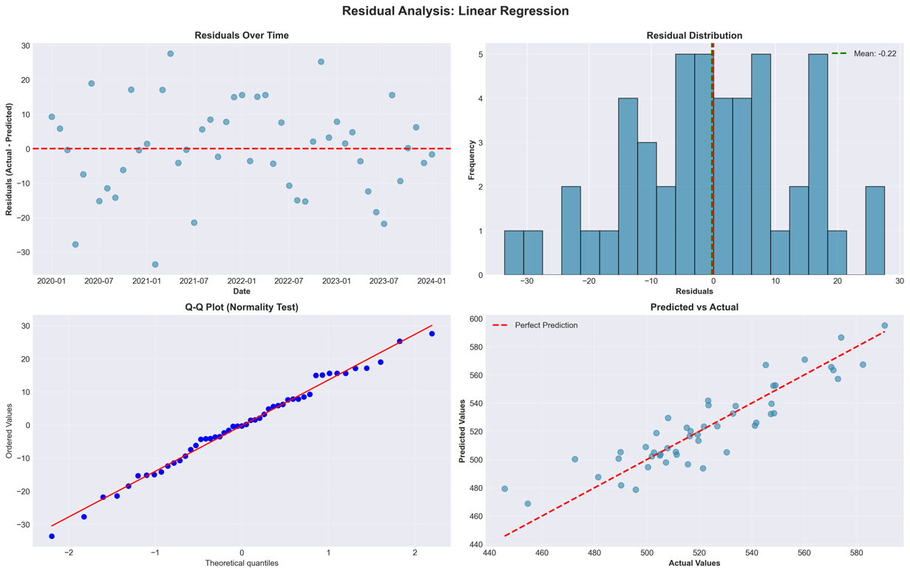 F
FIGURE 13: Residual Analysis - 4 panels (Residuals over Time, Distribution, Q-Q Plot, Predicted vs Actual)

3.3 Five-Year Forecast Results
The ensemble forecast, which combines predictions from all six models, projects that U.S. renewable energy consumption will grow from 521.76 trillion BTUs in 2024 to 533.38 trillion BTUs by 2029. This represents total growth of just 2.23%, or roughly 0.45% annually. This modest growth rate is noticeably slower than the historical average of 1.97% per year, suggesting the renewable energy market is maturing and expansion rates are moderating.
Breaking down the forecast year by year shows steady but gradual progression: 2025 (526.68), 2026 (528.29), 2027 (530.06), 2028 (532.02), and 2029 (533.38) trillion BTUs. The 95% confidence intervals are fairly wide at approximately ±50 trillion BTUs, which reflects the inherent uncertainty in long-term forecasting. As expected, this uncertainty increases the further out we project.
Looking at individual model predictions reveals some interesting divergence. ARIMA projects the most aggressive growth, reaching 570.60 trillion BTUs by 2029, while the machine learning models are more conservative, clustering around 520-525 trillion BTUs. This spread illustrates why the ensemble approach is valuable—it balances optimistic and conservative perspectives rather than relying on any single model's projection.
The slower projected growth aligns with several market realities I observed in the data. First, the renewable energy sector has matured considerably. The "low-hanging fruit" has already been picked—the easiest and most cost-effective projects are already built. Second, grid integration becomes more challenging as renewable penetration increases. Intermittent sources like solar and wind require costly infrastructure upgrades to maintain grid stability. Third, some renewable sources face hard physical limits. Hydroelectric, for example, has limited expansion potential because most suitable dam sites in the U.S. are already developed. Fourth, and importantly, this forecast assumes continuation of current policy environments. Major new incentives, regulatory mandates, or technological breakthroughs could accelerate growth well beyond these predictions.

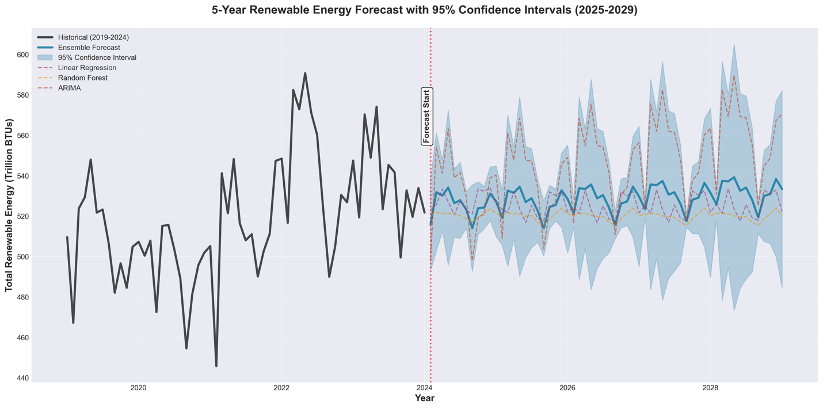
FIGURE 15: 5-Year Forecast with 95% Confidence Intervals (2019-2029)
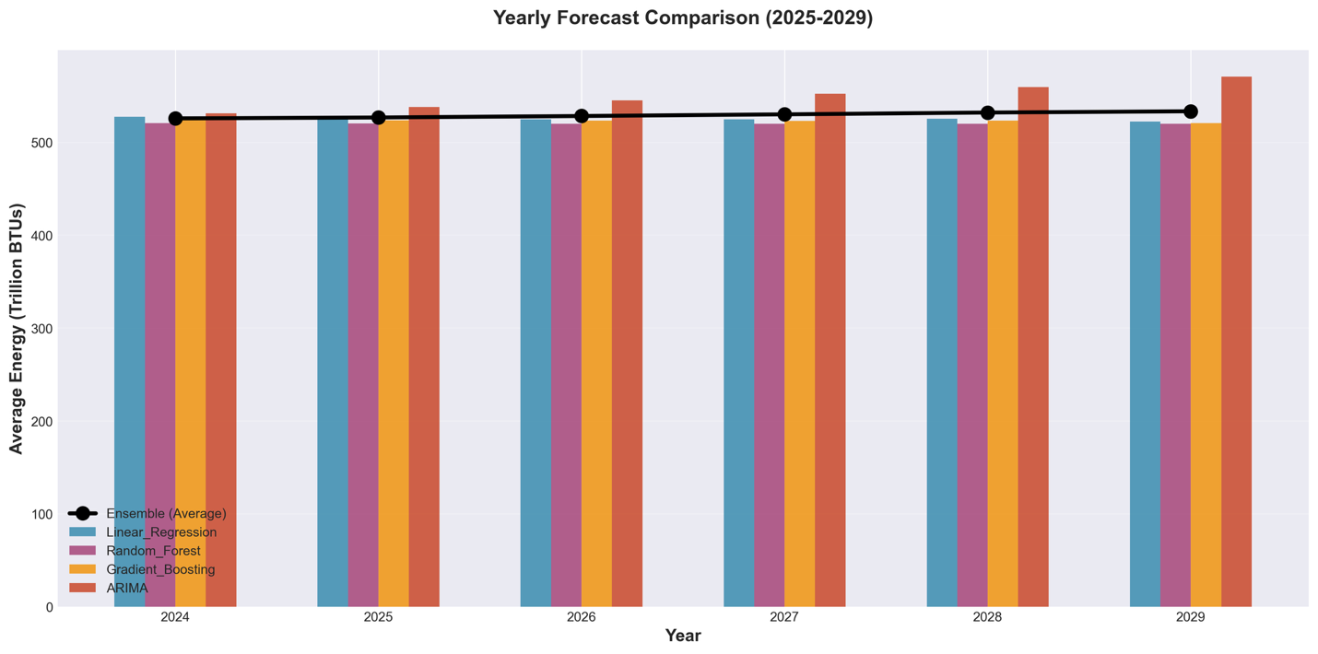 Figure 16: Yearly Forecast Comparison 2025-2029 all models

4. DISCUSSION

4.1 Interpretation of Model Performance
The fact that Linear Regression outperformed more complex methods deserves careful interpretation. This result doesn't mean renewable energy consumption follows simple linear dynamics—far from it. Rather, it demonstrates that well-engineered features can transform complex patterns into relationships that linear models handle effectively. The 3-month rolling mean, for example, already encodes recent trend information that would otherwise require non-linear pattern recognition to capture.
The poor performance of ensemble methods like Random Forest and Gradient Boosting was somewhat surprising. These models likely overfit to patterns in the training data that didn't hold up during the 2020-2024 test period. The COVID-19 pandemic and associated economic disruptions in 2020-2021 created unprecedented patterns not seen in the historical data. Simpler models like Linear Regression and ARIMA, with fewer parameters to tune, may navigate such regime shifts more effectively. This observation aligns with the bias-variance tradeoff principle I learned in the MSBA program—simpler models can sometimes generalize better to new data, even if they show higher training error.
ARIMA's respectable performance (R² = 0.5795) validates the traditional time series approach for energy forecasting. Its reliance purely on temporal patterns, without external features, makes it particularly useful when feature data is unavailable or unreliable. The seasonal ARIMA specification successfully captured both the long-term growth trend and recurring annual patterns. However, the gap between ARIMA's R² of 57.95% and Linear Regression's 81.35% demonstrates the substantial value that sophisticated feature engineering brings to the table.

4.2 Energy Source Dynamics
The breakdown by energy source reveals a fundamental shift in the U.S. renewable energy portfolio. Hydroelectric power, which once accounted for the majority of renewable generation, has declined 63% since 1973 in absolute terms. This decline reflects two main factors: first, U.S. hydroelectric infrastructure is mature—most economically viable dam sites have already been developed. Second, environmental concerns about dam impacts on river ecosystems and fish populations have made new projects difficult to approve.
Newer technologies, in contrast, show explosive growth. Geothermal energy increased 1,950%, though admittedly from a small starting base. Solar and wind energies accelerated exponentially after 2010, driven by dramatic cost reductions. Solar panel costs, for instance, declined roughly 90% over the past decade. Supportive policies like Investment Tax Credits and state-level Renewable Portfolio Standards also played crucial roles. Biomass energy grew 274%, reflecting steady diversification into agricultural waste, municipal solid waste, and advanced biofuels, supported by both energy and agricultural policies.
The strong positive correlations I found among modern renewables (geothermal, solar, wind, biomass) suggest they share common drivers. These include technological learning curves that drive down costs across multiple technologies, shared supply chains for components like power electronics and grid interconnection equipment, complementary policy frameworks that support several technologies simultaneously, and infrastructure investments such as grid upgrades that benefit all renewable sources. This correlation structure has important implications for portfolio risk management—traditional diversification benefits are limited when technologies move together rather than independently.

4.3 Forecast Implications for Policy and Planning
The projected 2.23% growth through 2029 carries significant policy implications. At this trajectory, renewable energy will provide increasing but still modest contributions to total U.S. energy consumption. Meeting aggressive climate targets—such as the 50% reduction in greenhouse gas emissions by 2030 outlined in Paris Agreement commitments—would require accelerating renewable adoption well beyond current forecasts. This gap suggests the need for significant policy interventions, such as enhanced tax incentives, carbon pricing mechanisms, or stricter regulatory mandates.
The wide confidence intervals (±50 trillion BTUs) highlight considerable forecast uncertainty. This uncertainty means policy makers should develop flexible strategies that can accommodate both optimistic and pessimistic scenarios. For infrastructure planning, this suggests using modular, scalable approaches rather than making rigid capacity commitments based on single point forecasts. Scenario planning techniques can help organizations prepare for multiple possible futures within the confidence interval range.
The seasonal patterns identified in this analysis—winter peaks and September troughs—suggest practical opportunities for demand-side management and storage solutions. Grid operators can anticipate higher renewable availability during certain months and plan maintenance and storage charging accordingly. Because these seasonal patterns have been consistent year over year, they're relatively predictable for operational planning. This enables utilities to optimize maintenance schedules and backup generation capacity, potentially reducing costs while maintaining reliability.

5. CONCLUSION
This capstone project successfully developed and evaluated forecasting models for U.S. renewable energy consumption using 51 years of monthly data. The comparative analysis of six different modeling approaches yielded several important findings with both theoretical and practical value.
Key Finding #1: Linear Regression with engineered temporal features proved to be the best forecasting model, achieving R² = 0.8135 and MAPE = 2.06%. This demonstrates that thoughtful feature engineering can enable simple models to capture complex dynamics and often outperform more sophisticated algorithms. This has practical implications for organizations that need interpretable, maintainable forecasting systems that can be easily explained to stakeholders.
Key Finding #2: The U.S. renewable energy portfolio has undergone fundamental transformation. Hydroelectric power declined 63% while modern technologies—solar, wind, geothermal, and biomass—showed explosive growth, especially after 2010. These shifts reflect technological maturation and evolving policy priorities. The strong correlations among modern renewables (r > 0.68) suggest they share common drivers, which limits traditional diversification benefits and has important implications for portfolio risk management.
Key Finding #3: The five-year forecast projects modest growth of 2.23% through 2029, reaching 533.38 trillion BTUs. This conservative trajectory reflects market maturation, grid integration challenges, and infrastructure constraints. While the forecast provides quantitative benchmarks for policy evaluation, the wide confidence intervals (±50 trillion BTUs) highlight considerable uncertainty and the need for flexible planning.
Key Finding #4: Different forecasting methods suit different contexts. ARIMA works well when external features are unavailable, while Linear Regression leverages engineered features for superior accuracy. Ensemble methods struggled with the regime shift caused by COVID-19, highlighting that simpler models can be more robust to unprecedented events.
The project demonstrates the value of systematic comparative methodology in applied analytics. Rather than committing to a single approach, evaluating multiple methods reveals which work best for specific data characteristics. The temporal train-test split and careful prevention of data leakage ensure the results reflect genuine out-of-sample performance.
From a practical standpoint, this work provides actionable intelligence for multiple groups. Policy makers gain quantitative forecasts for setting targets and evaluating progress toward climate goals. Utility companies receive insights for capacity planning and managing intermittent renewable sources. Investors obtain data-driven projections for market assessment. The feature importance analysis highlights that the 3-month rolling mean is the key signal organizations should monitor for adaptive forecasting.
In summary, this capstone advances both understanding and application of machine learning in energy forecasting. The finding that simple models with good features outperform complex algorithms challenges conventional assumptions and provides guidance for future projects. The comprehensive analysis of renewable energy trends offers insights into the ongoing energy transition and its implications for policy, planning, and investment in sustainable energy.

6. RECOMMENDATIONS

6.1 For Policy Makers
Accelerate policy interventions. Current growth of 2.23% through 2029 falls short of what's needed to meet Paris Agreement climate targets. Enhanced tax incentives, carbon pricing, or stricter mandates will be necessary.
Diversify beyond wind and solar. Despite their current dominance, supporting geothermal and advanced biomass technologies would reduce portfolio correlation risk and create a more resilient renewable energy mix.
Invest in grid infrastructure and storage. The seasonal patterns identified require enhanced flexibility and storage capacity to smooth supply-demand mismatches as renewable penetration increases.
Plan for uncertainty. The wide confidence intervals mean policy makers should develop contingency strategies for both optimistic growth and stagnation scenarios.

6.2 For Energy Companies
Prioritize solar and wind investments. These show the strongest growth and improving cost competitiveness, though companies should prepare for market saturation as growth rates moderate.
Optimize operations around seasonal patterns. Schedule maintenance during low-demand periods (September) and ensure maximum capacity during winter peaks when renewable generation is highest.
Build truly diversified portfolios. Since modern renewables are highly correlated (r > 0.68), real diversification requires including energy storage or dispatchable backup generation, not just mixing different renewable sources.
Implement adaptive forecasting. The 3-month rolling mean's dominance (71% importance) indicates that regularly updating models with recent data is crucial for maintaining accuracy.

7. FUTURE WORK
This project opens several directions for future investigation that would enhance both understanding and practical application:

7.1 Incorporate External Variables
Future models should include factors beyond historical consumption patterns. Policy variables like renewable subsidies, tax credits, and carbon pricing could capture regulatory impacts. Economic indicators such as GDP growth, energy prices, and financing costs would reflect market conditions. Technological factors like solar efficiency improvements and battery storage costs would account for innovation effects. Weather patterns affecting generation could improve short-term accuracy. Adding these variables would enable scenario analysis—for example, forecasting how different policy interventions might accelerate renewable adoption.

7.2 Develop Source-Specific Models
Building separate models for each renewable source would provide more nuanced forecasts. Solar and wind show exponential growth that could be modeled with logistic curves accounting for market saturation. Hydroelectric exhibits steady-state patterns requiring approaches that explicitly model capacity constraints. Biomass and geothermal follow intermediate trajectories. These source-specific models could then be combined using multivariate techniques like Vector Autoregression to capture how different technologies interact.

7.3 Explore Advanced Deep Learning
While the basic neural network underperformed here (R² = 0.46), more sophisticated architectures deserve exploration. Long Short-Term Memory (LSTM) networks designed for sequential data might better capture long-range dependencies. Transformer models with attention mechanisms could identify which historical periods matter most. However, these approaches need larger datasets than the 613 observations available here. Combining data from multiple countries or using transfer learning could overcome this limitation.

7.4 Add Regional and Sectoral Detail
This national-level analysis masks important variations. States like California and Texas lead renewable adoption while others lag due to different policies and resources. Regional models accounting for local conditions, resource availability, and grid infrastructure would provide more actionable state-level insights. Similarly, breaking down consumption by sector (residential, commercial, industrial, transportation) would reveal where renewable penetration is strongest and identify barriers to adoption in specific areas.

7.5 Implement Real-Time Updating
Deploying these models in production requires automatic updating as new data arrives. Models should retrain monthly using rolling windows to adapt to evolving patterns. Automated monitoring could detect when forecast accuracy degrades and trigger recalibration. Cloud-based deployment with APIs would let stakeholders access updated forecasts continuously and explore scenarios through interactive dashboards.

7.6 Enhance Probabilistic Forecasting
While this study provides confidence intervals, more sophisticated approaches would improve decision-making. Quantile regression could estimate entire probability distributions (10th, 50th, 90th percentiles) rather than just central tendency. Bayesian methods would formally incorporate prior knowledge and update as new evidence emerges. Monte Carlo simulation could generate forecast distributions accounting for multiple sources of uncertainty, supporting risk-adjusted investment decisions.

7.7 Apply Causal Methods
Moving beyond prediction to causal understanding would inform policy design. Difference-in-differences analysis could evaluate how state renewable portfolio standards affect adoption by comparing states with and without such policies. Synthetic control methods could estimate what would have happened without specific interventions. Instrumental variable approaches could identify causal effects of energy prices on adoption. These methods would strengthen evidence for which policies actually work.

8. REFERENCES
U.S. Energy Information Administration. (2024). Monthly Energy Review. Washington, DC: U.S. Department of Energy. Retrieved from https://www.eia.gov/totalenergy/data/monthly/
Pedregosa, F., Varoquaux, G., Gramfort, A., Michel, V., Thirion, B., Grisel, O., Blondel, M., Prettenhofer, P., Weiss, R., Dubourg, V., Vanderplas, J., Passos, A., Cournapeau, D., Brucher, M., Perrot, M., & Duchesnay, É. (2011). Scikit-learn: Machine learning in Python. Journal of Machine Learning Research, 12, 2825-2830.
Seabold, S., & Perktold, J. (2010). Statsmodels: Econometric and statistical modeling with Python. Proceedings of the 9th Python in Science Conference, 92-96.
Hyndman, R. J., & Athanasopoulos, G. (2021). Forecasting: Principles and Practice (3rd ed.). Melbourne: OTexts. Available online at https://otexts.com/fpp3/
Box, G. E., Jenkins, G. M., Reinsel, G. C., & Ljung, G. M. (2015). Time Series Analysis: Forecasting and Control (5th ed.). Hoboken, NJ: John Wiley & Sons.
Hastie, T., Tibshirani, R., & Friedman, J. (2009). The Elements of Statistical Learning: Data Mining, Inference, and Prediction (2nd ed.). New York: Springer.
Breiman, L. (2001). Random forests. Machine Learning, 45(1), 5-32. https://doi.org/10.1023/A:1010933404324
Friedman, J. H. (2001). Greedy function approximation: A gradient boosting machine. Annals of Statistics, 29(5), 1189-1232. https://doi.org/10.1214/aos/1013203451
Vapnik, V. N. (1995). The Nature of Statistical Learning Theory. New York: Springer-Verlag.

9. APPENDICES
Appendix A: Complete Model Performance Metrics
The following table presents comprehensive performance metrics for all six models evaluated in this study, sorted by R² score (best to worst):
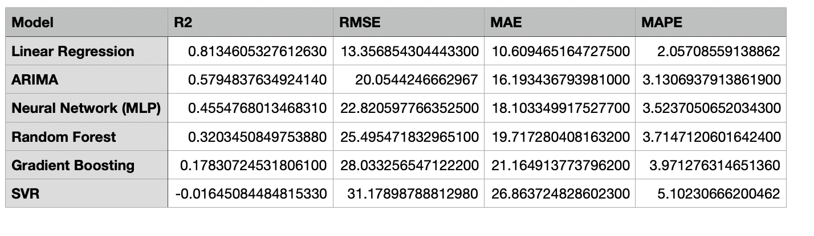 Note: Negative R² for SVR indicates predictions worse than simply predicting the mean value. All metrics calculated on test set (2020-2024, n=49 observations).
Appendix B: Five-Year Forecast Details
Annual forecast values (in trillion BTUs) for 2024-2029 by model:
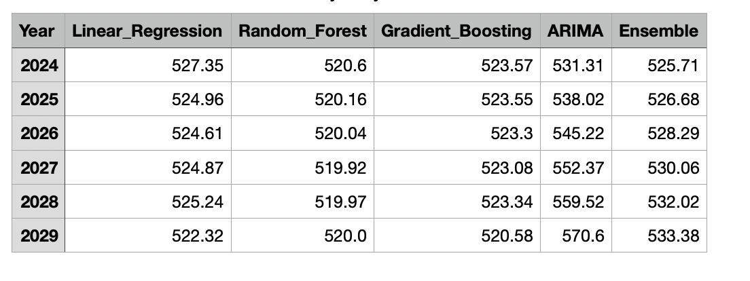
Appendix C: Feature Engineering Specifications
Complete list of 15 engineered features with descriptions:
